**Name:- Divyang Bagla**

**ERP ID:- 1032180739**

**Batch A2**

**Roll No. :- PC33**

**Lab Assignment No. 3**

**Aim:-** 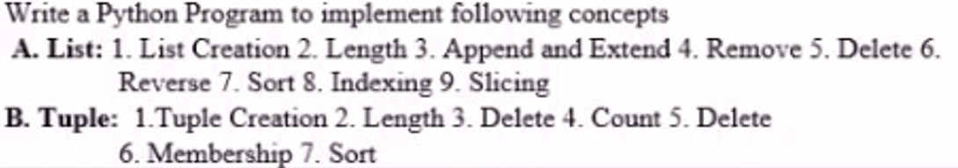

**Theory: -**

**List**

**Definition:** Lists are used to store multiple items in a single variable.

Lists are one of 4 built-in data types in Python used to store collections of data, the other 3 are Tuple, Set, and Dictionary, all with different qualities and usage.

Lists are created using square brackets []

List Features:

1. Ordered
2. Mutable
3. Duplicates Allowed

**Tuples**

**Definition:** Tuples are used to store multiple items in a single variable.

Tuple is one of 4 built-in data types in Python used to store collections of data, the other 3 are List, Set, and Dictionary, all with different qualities and usage.

Tuples are created using parentheses ()

Tuple Features:

1. Ordered
2. Immutable
3. Duplicates Allowed

**Lab Assignment 3 Code**



